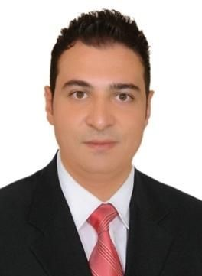

# ** Personal Information **

**First Name:**​ Samer ​ **Nationality:**​ Syrian

**Father’s Name:**​ Muhammed Ayman

Place and Date of Birth: Syria,1982 ​ **Residency:** ​Kurdistan Iraq

**Family Name:**​ Barakat ​**Mob:**​ 009647703687706

**\*\* Eduacation \*\***

.College of English literature Bachelor Degree, Al-Baa’th University, Syria

# **Skills and Characteristics **

​**\***Experienced manager, trainer, leader, and teacher

​**\*** ​Understanding Operations

* Planning for Business

​**\***​ Teamwork

​**\***​ professional Customer service with ability and experience to lead it

* Adaptability ​

**\***​ Drive for Result ​

**\***​ Precise at work

**\*** ability to convince others

Sales skills and sales management experience

# ​** Languages and Computer Skills**

Arabic is a mother tongue * English is fluent * Kurdish is good.

Microsoft Office is Excellent ​**\*** Commercial correspondence is excellent.​

# ** Work Experiences**

**Front Office Manager**

Masaya by Emerald (Cristal Group) 200 rooms five star hotel Erbil,Kurdistan Iraq August till October 2018.

**Restaurant and Housekeeping Manager**

Classy Hotel Four star Erbil, Kurdistan Iraq June 2018 up till August 2018

**General Manager Deputy**

Avenue Four Star Hotel, Kurdistan Iraq 1/9/2016 up

till June 2018.

## **Rooms Division Manager**

Avenue Four Star Hotel, Kurdistan Iraq 24/9/2017 up till the present.

**HOUSEKEEPING MANAGER**

Avenue Four Star Hotel, Kurdistan Iraq 2016 up till the present.

**FRONT OFFICE MANAGER**

Avenue Four Star Hotel, Kurdistan Iraq 2015 up till 24/9/2017.

**RECEPTION SHIFT LEADER**

High Crest Five Star Hotel, Kurdistan Iraq 2014-2015.

**RECEPTIONIST**

Titanic Five Star Hotel, Kurdistan Iraq 2014.

**Accountant junior**

Kajjoun import and export Co., Hama –Syria 2012-2013.

**Branch Manager and Sales Manager**

Issue wholesome magazine, Hama and Hims – Syria 2007-2011.

**Sales Manager**

Deri import & export Co, Hama-Syria 2005-2007.

### **Commercial Correspondences**

Deri import & export Co. Hama, Syria

Shawwaf Co. for Detergents.

**English Teacher**

2003-2013 Hama, Syria

* Lingua land laboratory (teacher of beginners and intermediate levels) three years 2007-2010
* AlNawair private school 2005-2006
* Private teacher 2003-2013

### **Basketball Coach**

Hama, Hims, and Damascus in Syria +Kurdistan Iraq 2004-2014.